**NAME:NICOLE GESARE**

**ASSIGNMENT 1:ENVIRONMENT SETUP**

**Operating System: Windows 11**

During the installation of windows 11 there are some steps I followed to ensure that I have a seamless installation and that was:

1. Check whether my system meets the minimum requirements for the installation of the operating system.
2. Downloaded the windows 11installation media from Microsoft download page.
3. Prepare for the installation media by running the media creation tool, creating the installation media, choosing the media type then selecting the USB drive.
4. Now the installation of windows 11 by: booting from USB drive, setting up windows, entering of the windows product key, selecting the installation type, partition of the drive then installation of Windows 11.
5. This is after the installation, its just the setting up of windows 11 which involves initial setup, signing in to your Microsoft account, customizing and then finalizing the setup and booting the desktop.

After this steps I had successfully installed windows 11 and set up my development environment.

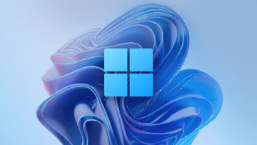

**Text Editor/IDE: Visual Studio Code**

- Downloaded and installed from visual Studio Code which is the official website.

-Followed the installation instructions that were provided on the website.

-Got to download visual studio community which is free .

I managed to successfully install visual studio code.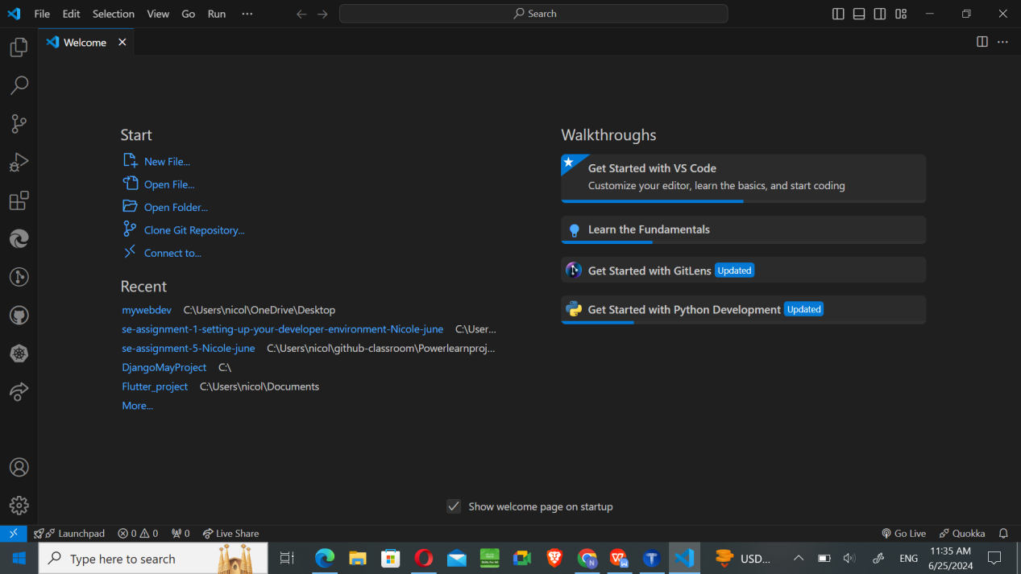

**Version Control: Git and GitHub**

Installed Git from the official website:Download Git.

Followed the installation instructions provided.

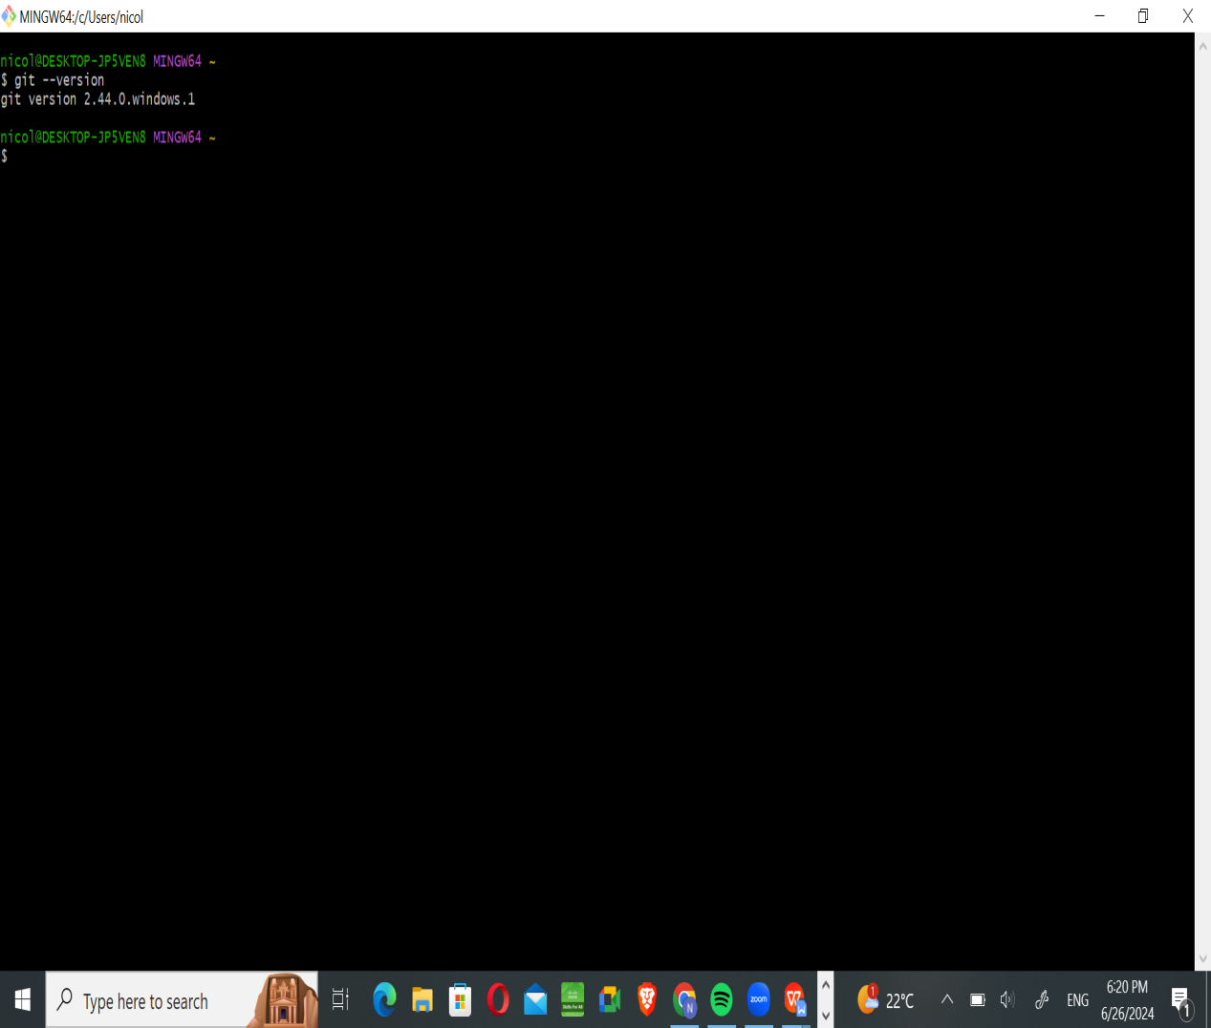

Created a GitHub account after I visited GitHub.

Initialized a Git repository and made the first commit.

This was made successful by typing some commands on the git bash terminal.

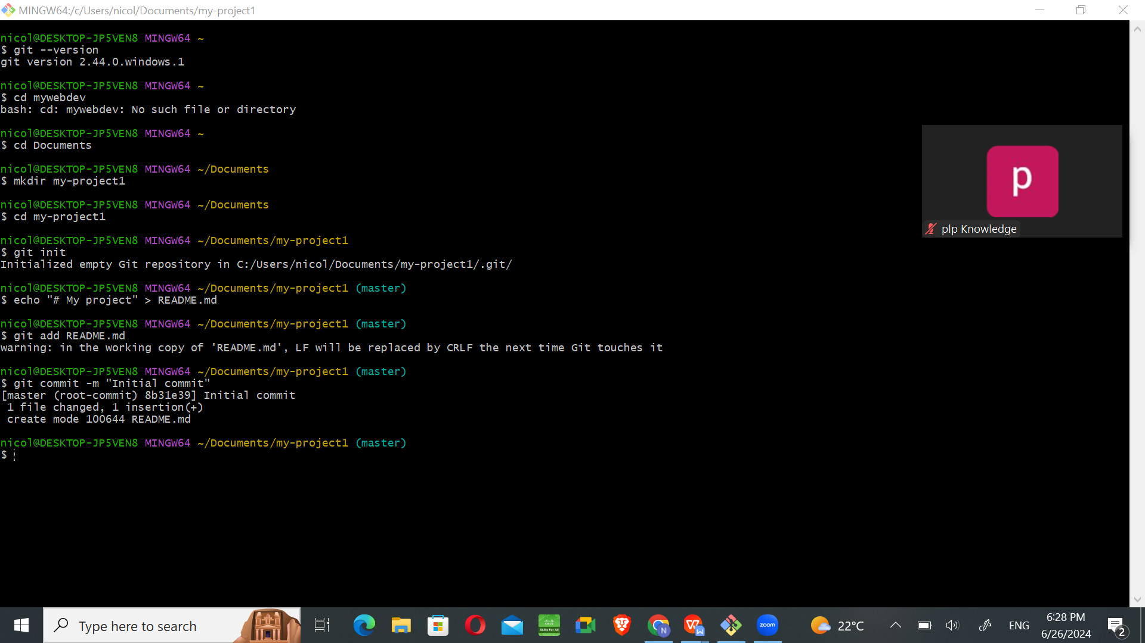

This was made simpler since the instructors gave a step by step process of the installation of both Git and opening of an account at GitHub.

**Programming Languages: Python**

- Installed Python from Download python.

-Followed the installation instruction and added python to my system PATH.

Installed pip the package installer for Python.

- Verified pip installation by checking the version of pip in the command prompt.

The command to check the version is pip --version.

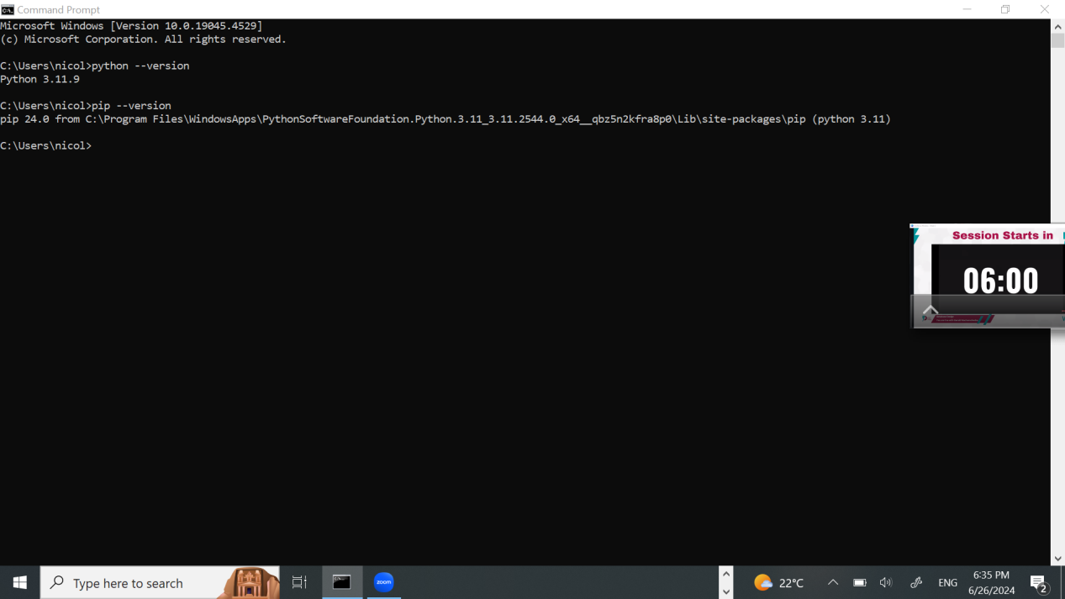

**Database: MySQL**

- Downloaded and installed MySQL from the official website:Download MySQL.

-Followed the installation instructions provided through the documentation and had a successful install.

**Extensions and Plugins:**

-First explored the extensions, plugins and add-ons for Vs Code to enhance functionality.

- Installed VS Code extensions: Python, GitLens, flutter and dart.

**Reflection**

During the setup process, I encountered very few challenges but it was due to some careless mistakes. To overcome these, I referred to the official documentation and community forums for solutions. This experience highlighted the importance of thorough documentation and leveraging community resources for troubleshooting. But never the less have great instructors taking us step by step made the process seamless.